1. **Is ELITEA an IP (Intellectual Property) of EPAM ? (Y/N)**

*YES. We have Epam License agreement that need to be signed by client in advance.*

1. **Is there a perpetual licensing model for ELITEA, other than the monthly/Annual subscription cost ?**

* *EPAMERS can use it for personal purpose with no additional cost.  Epam shared SaaS instance.*
* *Client should buy professional services with Elitea with monthly fix / consumption-based fee or we can provide Elitea with Support service only. In this case: EPAM SaaS Min 80 SPs ~ $6k, on premise installation Min 160 SPs ~ $12k monthly*

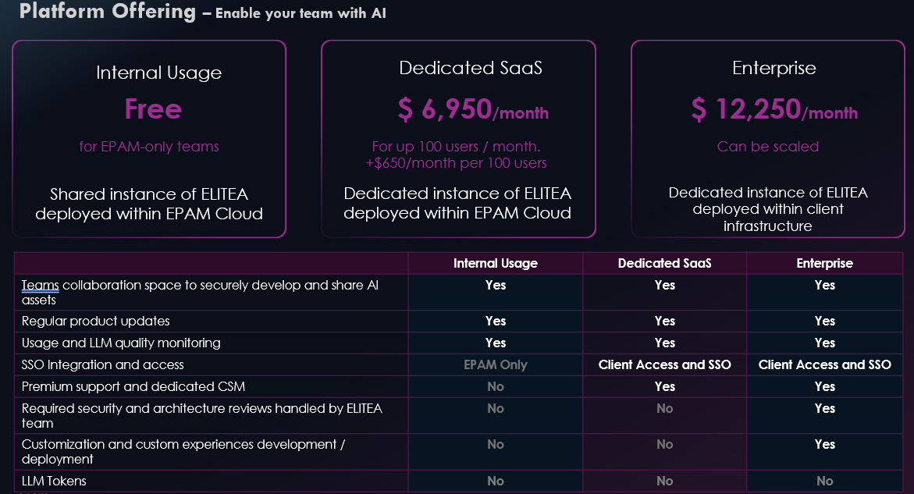

1. **Why is the infra cost same, for Hosted and Enterprise set-ups ? In my understanding of a hosted set-up, the infra cost is borne by customer. So why is it charged same as the Enterprise set-up (1700$ per month for 200 active users) ?**

*For both options, clients will pay the same amount.*

*in case of EPAM hosted - to****EPAM****,*

*in case of Enterprise to****Cloud provided directly****.*

Cost of Support will be different, because when we control hosting, we are able to support it without additional communication with their DevOps team, etc.

1. **I see that we charge 250 USD per month for every +100 active users. In situations where we have an incremental list of 5s or 10s or 50s of user additions, should I still pay a fixed price of 250 USD extra ? Or is there a 'per user' cost model ?**

* *First of all, we take into account "Active users" (who regularly use Elitea and LLMs for their routine).  So, the client will be able to add any number of users to Elitea. This is not user-based license.*
* *We provide a dedicated environment with fixed power of resources. This infrastructure supports up to 200 Active users, so when we see more and more wider adoption where client has more than 200 users, we propose to add additional node that will allow to support up to 100 more.  we can't up and down nodes based on  1, 10 ppl*

1. **For 200 active users, the total LLM usage cost comes to 120K (2.5*20*12*200) per year. Is that in addition to the licensing cost & infra cost ?**

**Example**: For a project with 200 active users, ELITEA cost per year would be **440.4K (split given below)  - Kindly confirm.**

* + Licensing cost - **300K** (150K licensing cost of 6 months * 2) *This is not just License. This is Support and professional services including PoCs, Agents development, Education and Coaching*
  + Infra cost - **20.4K**(1700 per month *12 )
  + LLM cost - **120K** (2.5*20 working days per month * 12)

*The reality is that we don't have enough statistic for 200+ users, let me check with guys from projects.*

*In general, teams reuse Agents, Datasources, do conversation with Elitea in a groups. It means that cost of LLM  less at scale.*

*Second, it they Use LLM with Elitea, it means that they use Agents, Assistants, Prompts and improve they productivity gain at list from 20%. Taking in to account average cost of employee ~ $350 / day  (350-20%=>70*20*12*200= $3.360M) taking in to account: infra 20.4k + Prof Services  300k + LLM even 120k they save $2.916Millions yearly 🙂*

1. **Could you explain us the cost of using ELITEA for a small-scale project that has only 50 Active users. This might be a simpler & practical scenario, for better understanding of the cost models, overall.**

*For small projects we could suggest a compromise:*

*EPAM Hosted Elitea:*

* *Infrastructure Cost $800 will be able to handle ~100 active users daily ( with limited monitoring features)*
* *LLM "Pay as you go"  ~$2.5 per day per user with soft limit f.e. $200 monthly*
* *Minimal Support Requirement: 80 SP/mo * - $3600*
* *(Optional) Professional Services : 0-360 SPs Monthly $0-16200 no location restriction/$23400 with location restriction.*
  + - *AI for PoCs*
    - *AI Agent Development*
    - *AI Usage in Education and Coaching*
    - *Tailored AI Consulting / Engineering*